NEWSLETTER – 6 MONTHS IN BENIN
This is our second newsletter since moving to Benin. We have done a lot since then – it feels as if we have already done 1 year! But alas, counting from when we started at the hospital in February 2015 to present, it is about 6 months.
We arrived in Benin in September 2014 after a long flight from London (via Paris). We arrived to a joyous entourage of the President of the Methodist Church – Bishop Alagbada; the President of the Women’s Fellowship and the President of the Youth Fellowship. We were taken to our accommodation in Akpakpa – PK6, where the final touches were being done. It is a pleasant house set in the EPMB (Eglise du Protestante Methodist Church of Benin) Galilee church compound. It is a quiet and peaceful place (as a church compound should be) and the outside space is safe enough for the girls to play and run unsupervised.
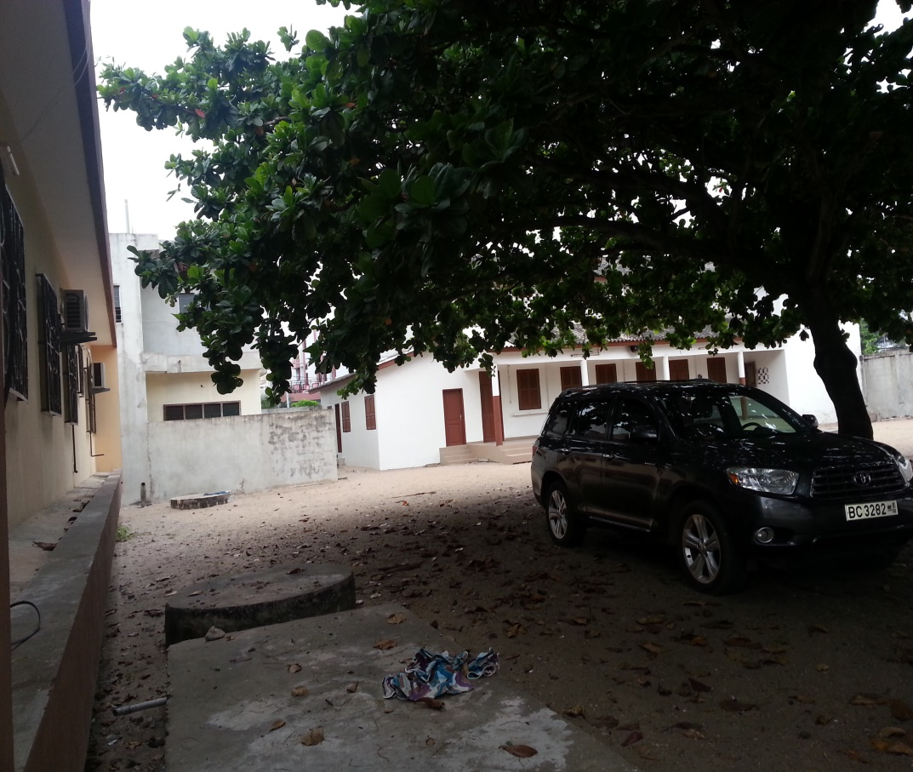
The back of our house on the left, the church to the right and the manse in the centre.
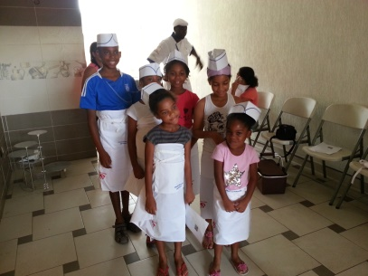The girls have settled well in school and are enjoying the extra-curricular activities which we could not get in Salone. These include tennis, ballet, contemporary African dance and swimming. As usual their friends hail from all around the world and the French language is heard nearly every day.

The girls with their friends at a Saturday baking class.
For the adults, we too had to go to school to learn the language at a basic functional level. This was done at the CEBELAE a well reputed French Language institute in Cotonou. Classes were from October to December 2014 and we both completed the A1 level of the language – and have certificates to show.
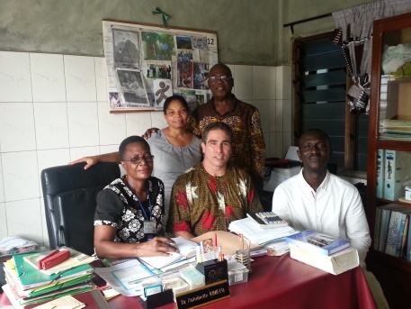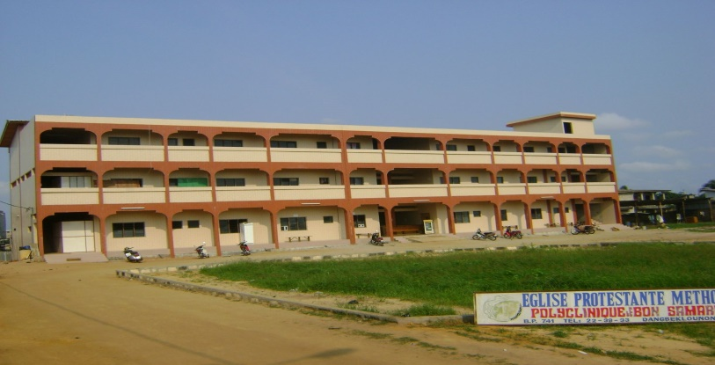
Polyclinic Bon Samaritan – where we work
In the New Year we started working at PBS (Polyclinic Bon Samaritan Hospital) in Porto Novo where we were introduced to the staff and promptly started working with the top management of the hospital. As was expected, there is much to do. The vast difference to Salone is that the major resource lacking is infrastructure (buildings). The hospital is housed in a 3 storey building – and as with any hospital – it offers general medicine, surgical, paediatrics and maternity care. However, unlike the hospitals in the UK, there is no elevator, and there is not enough space. We have seen on many occasions the very sick (unable to climb the stairs) being carried up (or down) on the back of a porter or a relative!! We have seen 2 newly delivered mums on one bed! We have seen new-born infants of mothers delivered by C-section being held in the arms of a relative until the mum can manage to care for them! So, the Wisdom of Solomon is needed here!
With Dr Antoinette (l) the Directrice, Constant (r) our interpreter and a potential partner Oscar (m)

There is much to be done and we have suggested various actions and activities to help improve some of the chronic problems facing the hospital – number one priority is finding extra space to cope with the number of patients that attend the hospital. In this regard we are making serious efforts to build a small administrative block to accommodate the administrative functions which are currently located in the main building. The challenge would be finding the funding for such a project. Small as it may be our resources are always stretched and such an undertaking would require the hospital either taking a loan from the bank (NOT our preferred option) or raising funds from partners, friends and other sources – our preferred option.
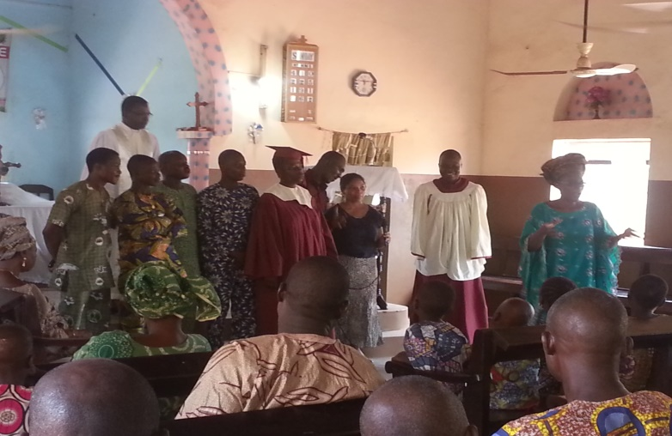Another aspect of our work has evolved in assisting the local church (envisioned and led by the Hospital Chaplin and EPMB’s Head of Health) to organise and promote health related talks in the church. The plan is that a group of 5 local churches will come together to choose health topics which will be presented over the course of 5 weeks. The presenters will be local health professionals in the church (or from the NGOs as needed) who will communicate the information in the local language. This project started on the 10th May at Betheseda d’Adjarra. The chosen topic was ‘Diabetes’ and the presenter was the EPMB’s Head of Health and Directrice of PBS – Dr Antoinette Kinniffo. We pray the project will continue smoothly.
Dr Antoinette (r), Joanna Tettey (3rd r) and the health committee at Adjarra Methodist Church, being introduced to the congregation
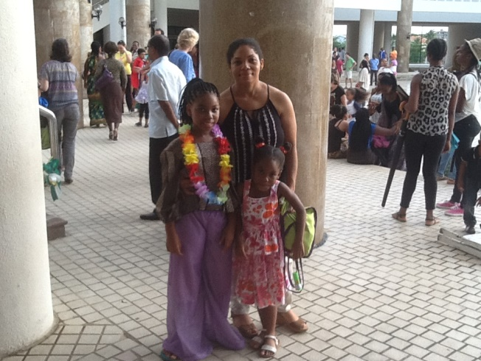
It has not been only work, work, work – but also some fun! On May 23rd Joelle participated in a dance show (‘spectacle’ – as it is called here), at the Palais the Congress – the equivalent of the National Theatre – in Cotonou. This made all the hard work put in by Joanna every Saturday morning taking Joelle to and from ballet classes worthwhile. Joelle and some of the pupils from the English International School were among approximately 350 pupils who took part in this ‘spectacle’. It was a good opportunity for Joelle to experience the hours of ‘fun’ on Saturday mornings being translated into a professional ‘spectacle’. The show was so exciting that Janelle who previously has refused all persuasion to leave her bed on Saturday mornings to attend ballet classes, has now decided to do so. We shall see.
A member of the choir presenting a summary of the talk
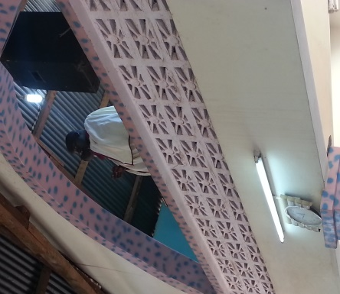
Please help us to pray for:
- Wisdom to know the systems that need to be urgently changed at the hospital to make it more efficient
- A miracle to get the finances that are needed to make the necessary urgent changes at the hospital
- The human resource needed to make the necessary urgent changes at the hospital
Joelle (in costume) with Joanna and Janelle after the show.
- The information at the church health talks to be effective in making the lives of the congregants better.
- The right persons to be used in the presentation of the church health talks

